Muhammad Balal Ansar

Week 4 Lab Task
Vulnerability Analysis
NIAI NAVTTC — Certified Ethical Hacker (CEH) Course
⚠ Important: All tasks must be performed only in your isolated virtual lab environment. Never test on real networks or systems without explicit written permission.

Task: Conduct a comprehensive vulnerability assessment across an organization's network infrastructure. Identify vulnerabilities in network devices, servers, and applications. Perform a risk analysis to prioritize and mitigate the identified vulnerabilities.

Option A — OpenVAS (Full Vulnerability Scanner)
▶ Set Up and Run OpenVAS
OpenVAS is built into Kali Linux. Run:
sudo gvm-setup # First-time setup — takes several minutes
sudo gvm-start # Start the service
Open your browser inside Kali and go to: https://127.0.0.1:9392
Log in with the credentials shown after setup.
Create a new scan target (use your Metasploitable IP) and run a Full and Fast scan.
Option B — Nmap Vulnerability Scripts (Quick & Lightweight)
▶ Run Nmap Vuln Scripts
nmap --script=vuln 192.168.56.101
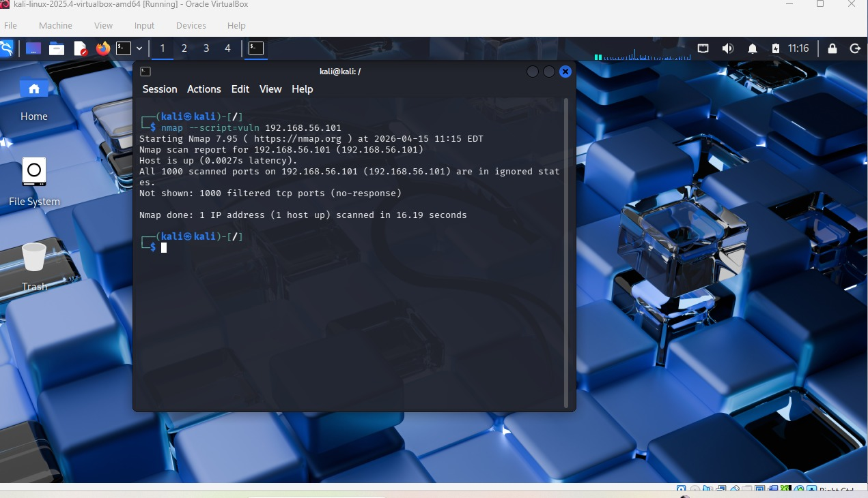
nmap --script=http-vuln* 192.168.56.101 # Web-specific vulns
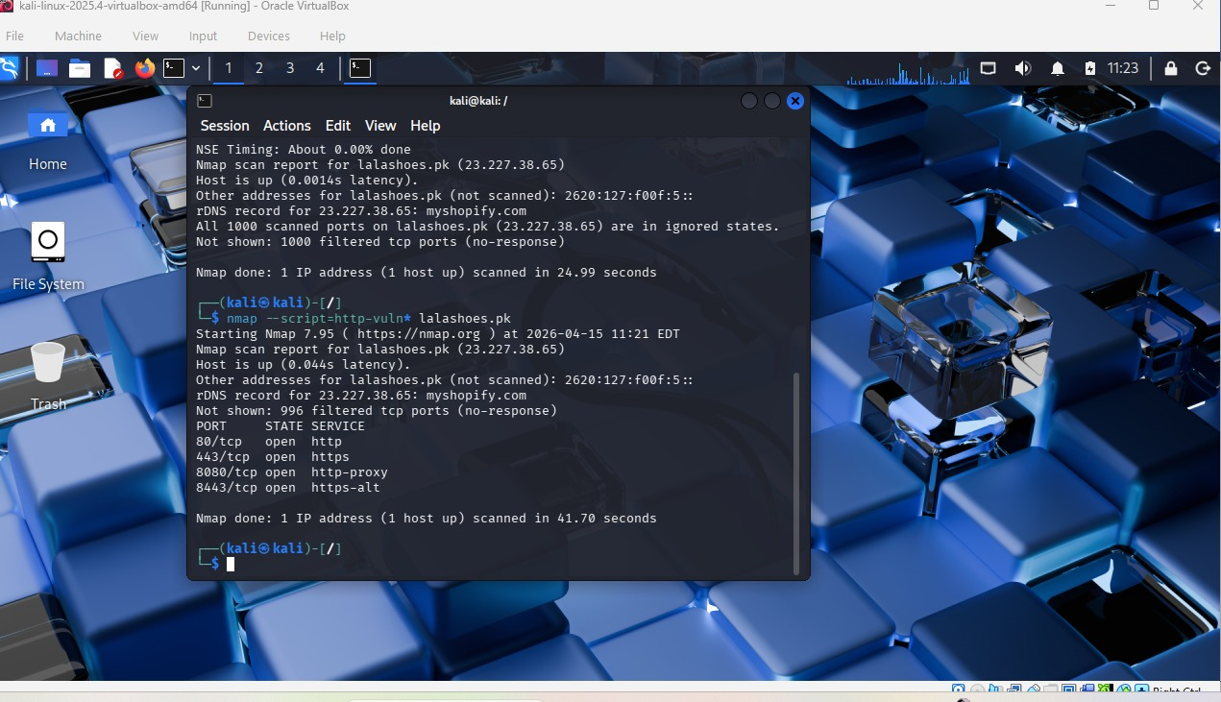

nmap --script=ftp-anon 192.168.56.101 # Check anonymous FTP

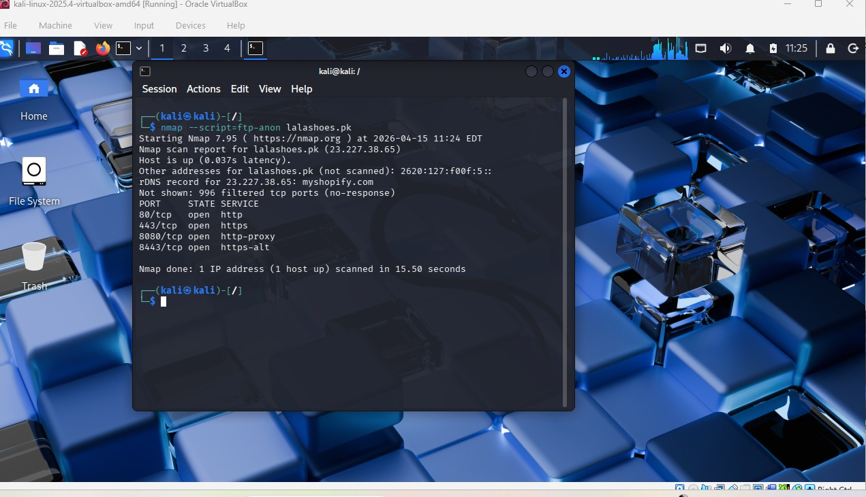
Option C — Nessus Essentials (Free for Students)
▶ Install and Use Nessus
Go to tenable.com/products/nessus/nessus-essentials and register for a free activation code.
Download and install Nessus Essentials on your host machine.
Open browser → https://localhost:8834 → Create a Basic Network Scan → target your Metasploitable IP.
Run the scan and review the vulnerability report.
Web Application Vulnerabilities
▶ Test the Metasploitable Web Server
Open a browser in Kali and go to: http://192.168.56.101
You will see a menu of vulnerable web apps (DVWA, Mutillidae, etc.).
Look for OWASP Top 10 issues such as:
- SQL Injection forms
- Old software version banners
- Directory listing enabled
- Default credentials still set
▶ Nikto — Web Server Scanner
nikto -h http://192.168.56.101
Nikto automatically checks for outdated software, misconfigurations, and common web vulnerabilities.
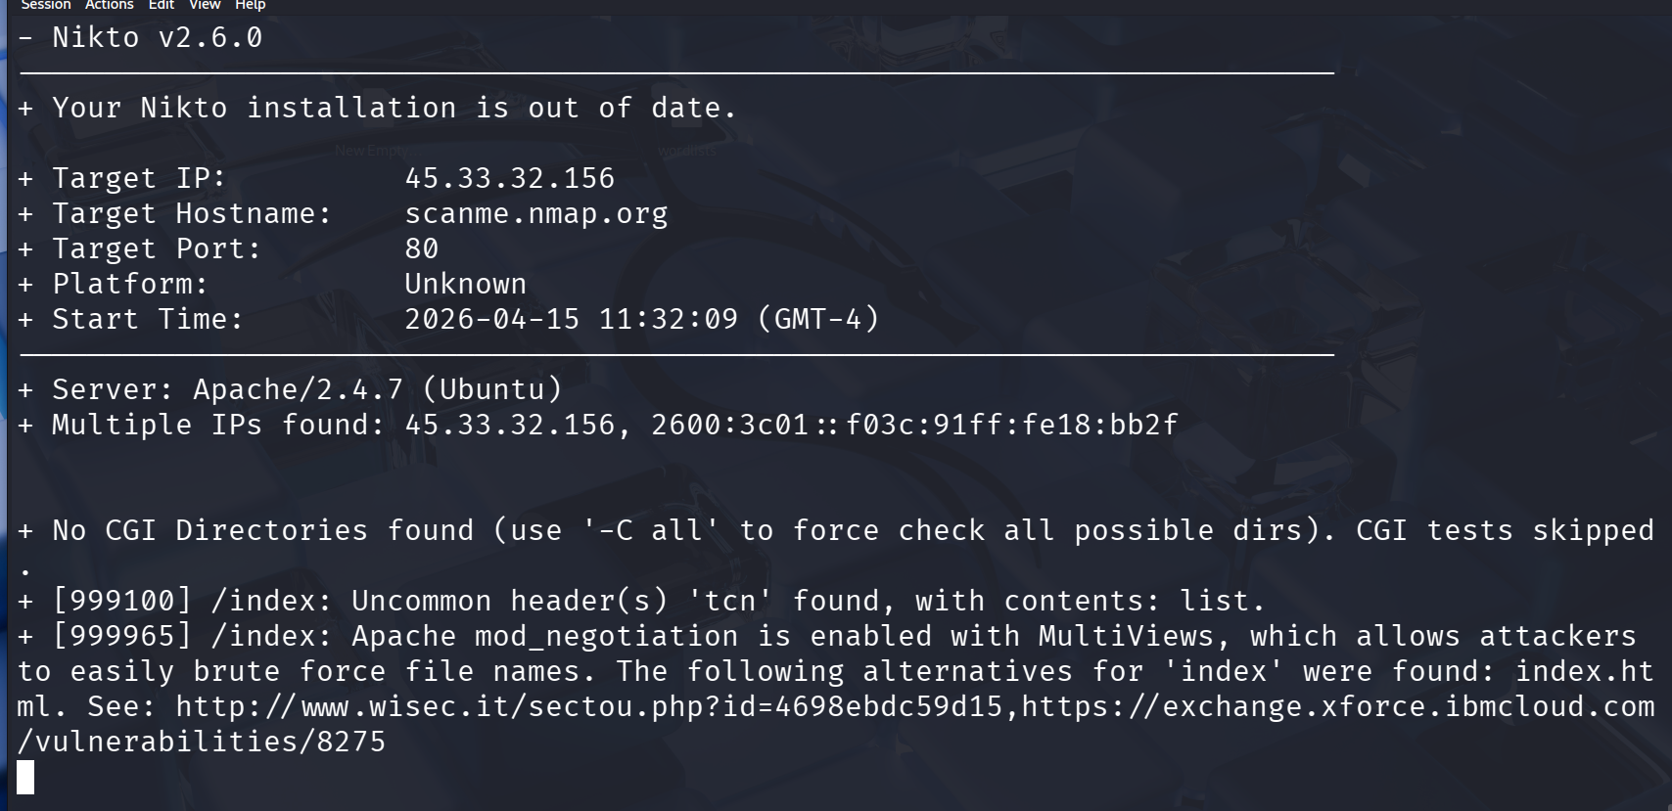
Risk Analysis & Report
▶ Create a Prioritized Risk Table
After scanning, organize your findings into a risk table like this example:
| Vulnerability | Severity | CVSS | Recommended Fix |
| FTP allows anonymous login | Critical | 9.8 | Disable anonymous FTP |
| Outdated Apache 2.2 | High | 7.5 | Upgrade to Apache 2.4+ |
| Open Telnet port 23 | High | 7.2 | Disable Telnet, use SSH |
| SMB Null Session allowed | Medium | 5.0 | Disable null sessions |
Prioritize Critical and High severity findings first.
For each vulnerability, note: what it is, how it was found, what it allows an attacker to do, and how to fix it.

Vulnerability | Severity | CVSS | How It Was Found | What It Allows Attacker To Do | Recommended Fix
Apache mod_negotiation (MultiViews) enabled | High | 7.5 | Nikto scan detected MultiViews enabled on web server | Allows attackers to brute-force or guess file names and discover hidden files/resources | Disable MultiViews and restrict mod_negotiation in Apache configuration
Outdated Apache version (Apache/2.4.7 Ubuntu) | Medium | 6.5 | Server banner detected in Nikto output | Version disclosure helps attackers identify known vulnerabilities and craft targeted exploits | Update Apache to latest stable version and hide server version headers
Uncommon HTTP header ‘tch’ detected | Low | 3.0 | Nikto identified unusual/custom header in HTTP response | May leak internal configuration or be used for fingerprinting the server | Remove unnecessary custom headers or sanitize HTTP responses
Directory indexing alternatives found (index.html variations) | Medium | 5.8 | Nikto reported index file alternatives due to mod_negotiation | Can expose directory structure and allow attackers to enumerate files | Disable directory listing and enforce strict index file rules
CGI directory scan skipped (potential hidden risk) | Informational | N/A | Nikto note: CGI tests skipped | Potential missed CGI vulnerabilities if enabled | Force full CGI scan using -C all and secure/disable unused CGI scripts

Summary (Important for Assignment)
The scan of scanme.nmap.org revealed several information disclosure and configuration-related issues, mainly related to Apache server configuration. The most significant issue is the enabling of MultiViews (mod_negotiation), which could allow attackers to enumerate hidden files. Additionally, server version disclosure increases exposure to targeted attacks.
However, no critical exploitable vulnerabilities (like RCE or authentication bypass) were detected, as this is a controlled practice environment.

Priority Order (Important)
- 🔴 MultiViews (Highest Risk)
- 🟠 Apache version disclosure
- 🟡 Directory/index behavior
- 🟢 Custom header issue

Bottom of Form

🎯 Goal: A complete vulnerability assessment report with a prioritized risk table showing vulnerabilities found, their severity scores, and recommended remediation steps.

